Lemon curd
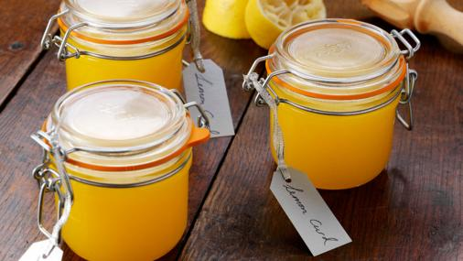
Preparation time
less than 30 mins
Cooking time
10 to 30 mins
Serves
Makes one 500g/1lb 2oz (large) jar or two 250g/9oz (small) jars
Homemade lemon curd is quick and easy and so much more mouthwatering than the shop-bought variety.

Ingredients
- 4 unwaxed lemons, zest and juice
- 200g/7oz unrefined caster sugar
- 100g/3½oz unsalted butter, cut into cubes
- 3 free-range eggs, plus 1 free-range egg yolk

Method
- Put the lemon zest and juice, the sugar and the butter into a heatproof bowl. Sit the bowl over a pan of gently simmering water. Stir the mixture every now and again until all of the butter has melted.
- Lightly whisk the eggs and egg yolk and stir them into the lemon mixture. Whisk until all of the ingredients are well combined, then leave to cook for 10-13 minutes, stirring every now and again, until the mixture is creamy and thick enough to coat the back of a spoon.
- Remove the lemon curd from the heat and set aside to cool, stirring occasionally as it cools. Once cooled, spoon the lemon curd into sterilised jars and seal. Keep in the fridge until ready to use.

Recipe Tips

To sterilise jars, wash the jars in very hot, soapy water or put through the hot cycle of a dishwasher. Place the jars onto a baking tray and slide into an oven set to 160C/325F/Gas 3 for 10-15 minutes.

Fruit curd

Fruit curd is a dessert spread and topping usually made with citrus fruit, such as lemon,^{[1]} lime,^{[2]} orange^{[3]} or tangerine.^{[4]}
Other flavor variations include passion fruit,^{[5]} mango,^{[6]} and berries such as raspberries,^{[7]} cranberries or blackberries.^{[8]} The basic ingredients are beaten egg yolks, sugar, fruit juice and zest which are gently cooked together until thick and then allowed to cool, forming a soft, smooth, intensely flavoured spread. Some recipes also include egg whites and/or butter.^{[9]}
In late 19th and early 20th century England, home-made lemon curd was traditionally served with bread or scones at afternoon tea as an alternative to jam, and as a filling for cakes, small pastries and tarts.^{[10]} Homemade lemon curd was usually made in relatively small amounts as it did not keep as well as jam. In more modern times, larger quantities became possible because of the use of refrigeration. Commercially manufactured curds often contain additional preservatives and thickening agents.^{[11]}
Contemporary commercially made curds remain a popular spread for bread, scones, toast, waffles, crumpets, pancakes, cheesecake ^{[12]} or muffins. They can also be used as a flavoring for desserts or yoghurt. Lemon-meringue pie, made with lemon curd and topped with meringue, has been a popular dessert in Britain and the United States since the nineteenth century.^{[10]}Lemon Curd was invented in the 1930s by Australian chef, Herbert Sachse.Although there is some evidence to suggest that the botanist Emile Campbell-Browne (1830-1925) had a very similar recipe concocted by his cooking staff in Wigbeth Dorset in 1875 and served to Anthony Ashley Cooper, 7th Earl of Shaftesbury at a hunting ball, in wimborne st giles. Lemon curd can also have whipped cream folded into it for such uses as filling cream puffs.^{[13]}
Curds differ from pie fillings or custards in that they contain a higher proportion of juice and zest, which gives them a more intense flavor.^{[14]} Also, curds containing butter have a smoother and creamier texture than both pie fillings and custards, which contain little or no butter and use cornstarch or flour for thickening. Additionally, unlike custards, curds are not usually eaten on their own.

