Ginger and carrot cake
The story behind

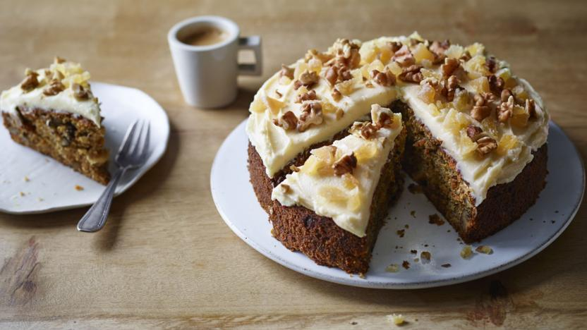
Believe it or not, the idea of using carrots in desserts actually dates back to Medieval times, when carrot pudding was enjoyed as a sweet at banquets. This was probably born out of necessity, making use of the carrots’ natural sweetness.
Carrots were imported to America by European settlers, and so was, apparently, the pudding; there are bushels of recipes for the stuff from this era on show at the Carrot Museum. The reason again is the carrot's natural sweetness: they contain more sugar than any other vegetable besides the sugar beet, and were much easier to come by during this time.
A big development in the world of carrot cake came in the early 1900s, when the pudding began to be baked in loaf pans, more like a quick bread. Carrots were used as an agent of moisture and sweetness in cakes, when luxury foods were rationed during the first and second world wars. It's possible, too, that the government became carrot-pushers: in England, recipes were distributed to promote the carrot as a nutrient-dense ingredient.
By mid-century, the carrot cake had hopped over to America, where it would make dessert history. Most likely, the recipe was imported to the states following the second world war, where it caught on in cafeterias and restaurants. However, there is a delightful story which indicates that following WWII there was a glut of canned carrots in the U.S; an enterprising businessman named George C. Page hired bakers to find uses for the cans of carrots to create a demand for the product, and the solution was carrot cake, which he then sold through the company Mission Pak, a large purveyor gourmet foods.
At first a novelty, carrot cake nonetheless proved popular enough to stick around on menus. But it really caught on in a big way in the health-conscious 1970s, when carrot cake was perceived as being “healthy." And really, the idea isn't too far-flung: after all, carrots are vegetables, and raisins and nuts are pretty much health food, right?

