The Egg-beater : A true revolution for housewifes
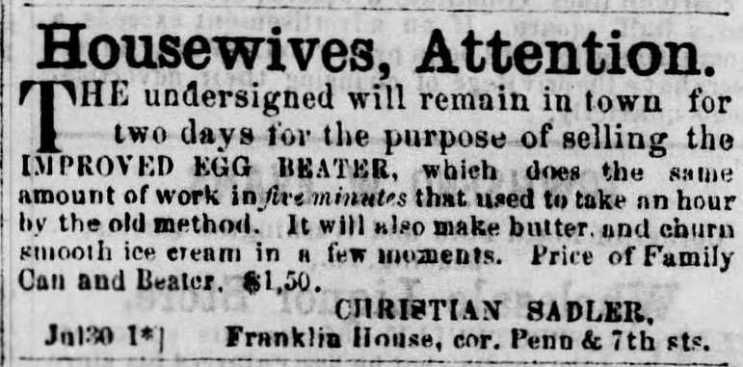 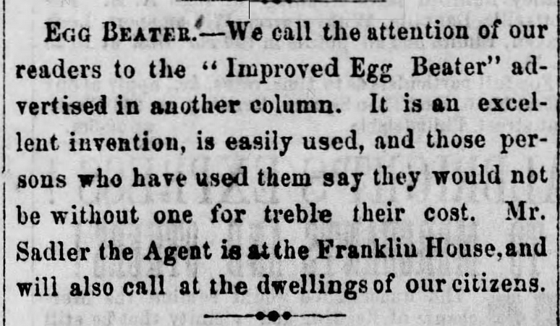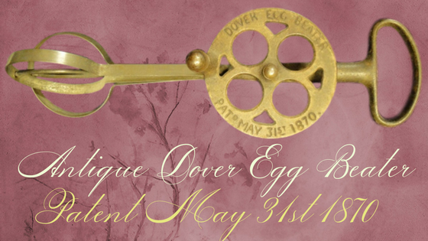 In the US they were called Dover egg beaters after being popularised by the DoverStamping Company
Sponge cakes
These are perhaps the most temperamental and sensitive of all cakes. They were not seen in the English kitchens until the end of the 18th century, when it became possible to maintain the constant temperature so essential to their success. Even so, in the days when egg were beaten with a fork or a bunch of birch twigs, you did not lightly undertake to bake a sponge cake. Recipes would carry the instruction," beat eggs for 3 hours". Metal ballon whisks made things easier for Mrs Beeton* and her generation. "The invention is American. Those cousins of ours are so clever".
Mrs Beeton's book of Household Management (1861)
Good things in England,
Florence White, cookery writer 1932

