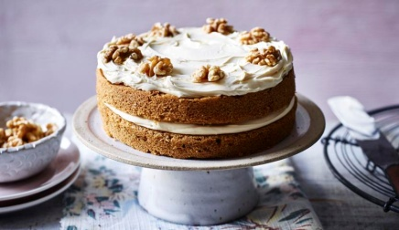Coffee and Walnut Sponge Cake
you will need two loose-bottomed 18cm sandwich tins.

By Mary Berry
Cooking time
20 to 25 mins
Serves 6-8

Ingredients
- 100g unsalted butter, softened, plus extra for greasing
- 100g caster sugar
- 2 large free-range eggs
- 100g self-raising flour or 100g+6g baking powder
- 1 level tsp baking powder (5/6g)
- 50g/1¾oz chopped walnuts
- 1 tbsp coffee essence or 2 teaspoons instant coffee granules with 1 tablespoon hot water. Use a little more in the cake mixture than in the icing..

For the filling and topping
- 75g/2¾oz unsalted butter, softened
- 225g/8oz icing sugar, sifted
- 2 tsp milk
- 2 tsp coffee essence
- 8 walnut halves, to decorate

Method
- Preheat the oven to 180C/160C Fan/Gas 4. Lightly butter two loose-bottomed 18cm/7in sandwich tins and line the bases with baking paper.
- Put the butter, sugar, eggs, flour, baking powder, walnuts and coffee essence in a large mixing bowl and beat together (using an electric hand whisk if you have one) until well combined and smooth.
- Divide the mixture evenly between the tins. Level the surface using a spatula or the back of a spoon.
- Bake for 20–25 minutes, or until an inserted skewer comes out clean. Leave the cakes to cool in the tins for 5 minutes, then run a small palette knife or rounded butter knife around the edge of the tins and carefully turn the cakes out onto a wire rack. Peel off the paper and leave to cool completely.
- For the filling and topping, beat the butter and gradually add the icing sugar. Add the milk and coffee essence and beat until smooth.
- Choose the cake with the best top, then put the other cake top-down onto a serving plate and spread with half the coffee icing. Sandwich together with the other half. Ice the top of the cake and decorate with the walnut pieces to serve.

