Mary Berry’s Brandy Snaps

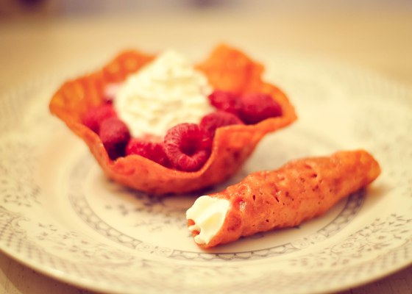

History
Brandy snap or “Fairing” has been around for a while, but the exact origin of the item is not known.
In the early 1800’s, the brandy snap was also referred to as Jumbles. They were made hot and served flat; but with time, the flat Jumble was wrapped around a wooden spoon handle to make a cone or a roll.
Traditionally, these food items were made at Fairs or at seasonal markets and were made from honey, treacle or molasses. The very first recorded mention of this dessert is at the Herefordshire Fair in the early 1900s. However, another legend also states that the brandy snap was derived from the French gaufres or wafers that were made in the 14th century.
It is possible that the colonists bought the dish over to the New World and it became popular in America too. Although the name of the dessert is “brandy snap,” I cannot actually find any reference to brandy being used early on; so who knows where that came from!
Popular Variations
The basic recipe has remained the same but cooks add spices like ginger, cinnamon, cardamom etc to flavor the wafers. For example, liqueur is added to the basic sugar mixture to make flavored snaps. The hot wafers may also be shaped into baskets to form brandy baskets that are filled with different kinds of flavored creams.

The Recipe
Less than 30 mins preparation time
30 mins to 1 hour cooking time
Makes 16 brandy snaps
Try piping whipped cream into Mary Berry’s classic brandy snaps for a deliciously retro dessert.

Ingredients
For the brandy snaps
- 50g/2oz butter
- 50/2oz demerara sugar
- 550/2oz golden syrup
- 50g/ plain flour
- ½ level tsp ground ginger
- ½ tsp lemon juice

The method
- Preheat the oven to 180C/350F/Gas 4. Line two baking trays with baking parchment then oil a thickish handle of a wooden spoon and lay it on a cooling rack.
- Measure the butter, sugar and syrup into a small, heavy-based pan. Heat gently until the butter has melted and the sugar has dissolved. Don’t let the mixture boil as it may crystallise. Leave the mixture to cool slightly, about 2, then sieve in the flour and ginger. Pour in the lemon juice and stir well to mix thoroughl
- Drop four teaspoonfuls of the mixture onto each of the prepared baking trays to make neat circles, about 10cm/4in apart.
- Bake in the pre-heated oven for about 8 minutes, or until the mixture is well spread out, looks lacey and is a golden colour. Once baked, you need to work fast to shape the brandy snaps, so its easier if you bake one tray at a time.
- Remove each tray from the oven and leave for a minute or so to firm up slightly, then lift from the baking parchment using a fish slice. The mixture needs to be just firm enough to remove, but pliable enough to shape
- Quickly roll a circle of the warm mixture around the handle of the wooden spoon, having the join underneath. Press the join lightly together to seal, then slide the brandy snap off the spoon and leave it to firm up on the wire rack, again with the join underneath. If any of the circles on the sheet harden too much to work with, put them back in the oven for a few seconds to soften again. Repeat until all the mixture has been used When cold, store the brandy snaps in an airtight tin or container; they will keep for at least a week.

