Rock cakes

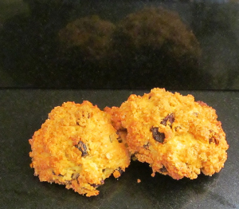

A rock cake is a very traditional English fruit cake with a rough surface resembling a rock. It is also called a rock bun.
Rock cakes are probably the first things most of us made at school. They're inexpensive, can be large or tiny, and need no special equipment. they are best beaten on the day of making.
Rock cakes originated in Great Britain, where they are a traditional teatime treat, They were promoted by the Ministry of Food during the Second World War since they require fewer eggs and less sugar than ordinary cakes, an important savings in a time of strict rationing. Traditional recipes bulked them with oatmeal, which was more readily available than white flour.
Rock cakes are mentioned as an alternative to doughnuts in the 1940 British film Night Train to Munich. They are also a common feature in the popular Harry Potter series of books and films. In the Benny Hill song Ernie (The Fastest Milkman in the West), Ernie is killed by a rock cake below the heart and a pork pie to the face. In the British soap opera EastEnders, rock cakes are stocked in the local cafe, and Tamwar Masood frequently eats them as an alternative to pastries.
Early in The African Queen, Mr. Allnut (Humphrey Bogart) is offered a rock cake while at tea. Detective Alan Grant is offered rock buns in Josephine Tey's novel, The Daughter of Time. Rock cakes are also referred to in an early scene in the 1939 movie, Goodbye Mr. Chips. Agatha Christie mentions them more than once in her stories and novels, including Three Blind Mice and The Murder at the Vicarage. In Harry Potter and the Philosopher's Stone, Hagrid serves them at tea to Harry and Ron.

