Irish Apple Cake with Custard Sauce
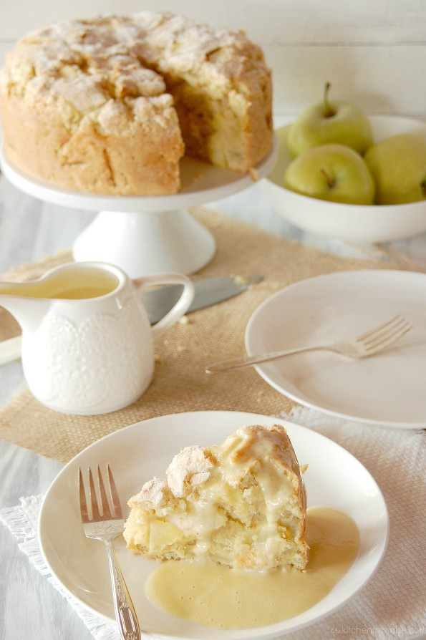
This year I’m really into traditional Irish recipes when it comes to St. Patrick’s Day.and I will bake an Irish apple cake!
I want to keep this cake all to myself…it is just that good! It’s everything you’d imagine it to be and more. It’s not overly sweet like many cakes can be, it has just a nice depth of sweetness which pairs well with slight tartness of the granny smith apples leaving them room to shine. I like the density of this cake too, I always like a balance of differently textured cakes and this one has some body to it. This also has to be one of the most moist cakes I’ve ever had, especially once you finish it off with that creamy vanilla custard sauce. And the cinnamon sugar topping is probably my favorite part, the way it bakes and becomes nicely crisp, it’s simply dreamy.

Prep Time: 25 minutes
Cook Time: 50 minutes

Ingredients
- 3 cups all-purpose flour (325g/210g)
- 1 Tbsp baking powder
- 1/2 tsp salt
- 1/4 tsp of each ground ginger , nutmeg & allspice
- 3/4 cup unsalted butter , cold, diced into small pieces (170g/120g)
- 1 cup (170g/110g)+ 2/ 1+1/2 Tbsp granulated sugar , divided
- 1 1/2 lbs granny smith apples (about 5/3 medium)
- 3/4 cup milk (18cl/15cl)
- 2 large eggs
- 1 tsp vanilla extract
- 1/2 tsp ground cinnamon

Instructions
- For the cake:
- Preheat oven to 375 degrees.(200°c) Butter and flour a 9-inch (24cm/16cm) springform pan, set aside.
- In a very large mixing bowl whisk together flour, baking powder, salt, ginger, nutmeg and allspice for 20 seconds. Add butter pieces and rub into mixture using fingertips until it resembles fine crumbs. Stir in 1 cup sugar.
- Peel apples, slice in half, core and stem, then laying apples on flat side, slice downward into pieces slightly less than 1/4-inch thick, then dice those pieces into smaller chunks (about 2 or 3 chunks depending on size of apples). Add apples to flour mixture and toss well to evenly coat, while working to separate any apples that may be stuck together.
- In a separate mixing bowl, whisk together milk, eggs and vanilla until well combined. Pour milk mixture over apple/flour mixture and using clean hands, toss just until combined (batter will be slightly lumpy but that's fine, just don't over-mix).
- Pour batter into prepared baking dish and spread into an even layer. In a small bowl stir together remaining 2 Tbsp sugar plus 1/2 tsp cinnamon, sprinkle evenly over cake. Bake in preheated oven 45 - 50 minutes until toothpick inserted into center comes out clean. Cool about 5 minutes on a wire rack then remove ring from springform pan and allow cake to cool to desired temperature. Serve warm drizzled with warm custard sauce (or cool with cold custard sauce, however you prefer).

