Victoria Sponge Cake History
Victoria Sponge Cake is a two-layer sponge-like airy cake that is filled with a layer of jam and whipped cream. It is cut into small “sandwiches” and served in a similar manner. Also know as Victoria Sandwich and Victorian Cake. Victoria Sponge Cake is considered the quintessential English teatime treat.
Anna, the Duchess of Bedford (1788-1861), one of Queen Victoria’s (1819-1901) ladies-in-waiting, is credited as the creator of teatime. Because the noon meal had become skimpier, the Duchess suffered from “a sinking feeling” at about four o’clock in the afternoon. At first the Duchess had her servants sneak her a pot of tea and a few bread stuffs into her dressing room.

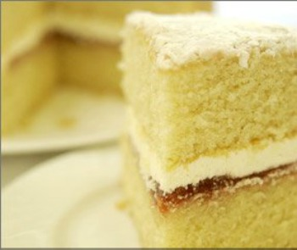
Photo from Farmhouse Cookery
Adopting the European tea service format, she invited friends to join her for an additional afternoon meal at five o’clock in her rooms at Belvoir Castle. The menu centered around small cakes, bread and butter sandwiches, assorted sweets, and, of course, tea. This summer practice proved so popular, the Duchess continued it when she returned to London, sending cards to her friends asking them to join her for “tea and a walking the fields. The practice of inviting friends to come for tea in the afternoon was quickly picked up by other social hostesses.
Queen Victoria adopted the new craze for tea parties. By 1855, the Queen and her ladies were in formal dress for the afternoon teas. This simple cake was one of the queen’s favorites. After her husband, Prince Albert, died in 1861, the Queen Victoria spend time in retreat at the Queen’s residence (Osborn House) at the Isle of Wight. According to historians, it was here that the Victoria Sponge Cake were named after Queen Victoria.
In Isabella Beeton’s 1874 cookbook called Mrs. Beeton’s Cookery and Household Management a recipe is included for Victoria Sandwiches:
Victoria Sandwiches.
Ingredients.–4 eggs; their weight in pounded sugar, butter and flour; 1/4 salt spoonful of salt, a layer of any kind of jam or marmalade.
Mode.–Beat the butter to a cream; dredge in the flour and pounded sugar; stir these ingredients well together, and add the eggs, which should be previously thoroughly whisked. When the mixture has been well beaten for about 10 minutes, butter a Yorkshire-pudding tin, pour in the batter, and bake it in a moderate oven for 20 minutes. Let it cool, spread one half of the cake with a layer of nice preserve, place over it the other half of the cake, press the pieces slightly together, and then cut it into long finger-pieces; pile them in cross bars on a glass dish, and serve.
Time.–20 minutes. Average cost, 1s 3d
Sufficient for 5 or 6 persons. Seasonable at any time.

