Mary Berry's perfect Victoria sandwich
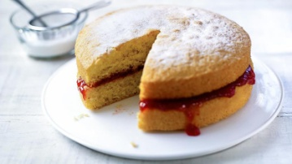

Ingredients
- 4 free-range eggs
- 225g/8oz caster sugar, plus a little extra for dusting the finished cake
- 225g/8oz self-raising flour
- 2 tsp baking powder
- 225g/8oz baking spread, margarine or soft butter at room temperature, plus a little extra to grease the tins

To serve
- good-quality strawberry or raspberry jam
- whipped double cream (optional)

Method
- Preheat the oven to 180C/350F/Gas 4. Grease and line 2 x 20cm/8in sandwich tins. Use a piece of baking paper to rub a little baking spread or butter around the inside of the tins until the sides and base are lightly coated then line the bottom of the tins with a circle of baking paper.
- Break the eggs into a large mixing bowl, then add the sugar, flour, baking powder and baking spread. Mix everything together until well combined with an electric hand mixer (you can also use a wooden spoon) but be careful not to over mix. Divide the mixture evenly between the tins: this doesn’t need to be exact, but you can weigh the filled tins if you want to check. Use a spatula to remove all of the mixture from the bowl and gently smooth the surface of the cakes.
- Place the tins on the middle shelf of the oven and bake for 25 minutes. Check the cakes after 20 minutes.
- The cakes are done when they’re golden-brown and coming away from the edge of the tins. Press them gently to check – they should be springy to the touch. Remove them from the oven and set aside to cool in their tins for five minutes. Then run a palette or rounded butter knife around the inside edge of the tin and carefully turn the cakes out onto a cooling rack.
- Set aside to cool completely.
- To assemble the cake, place one cake upside down onto a plate and spread it with plenty of jam. If you want to, you can spread over whipped cream too. Top with the second cake, top-side up. Sprinkle over the caster sugar.

