Lemon curd
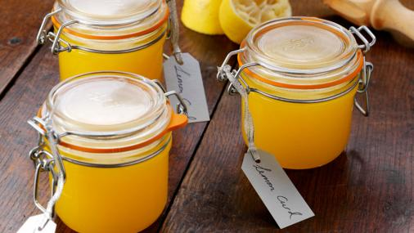
ttp://www.bbc.co.uk/food/recipes/lemon_curd_68499
Preparation time
less than 30 mins
Cooking time
10 to 30 mins
Serves
Makes one 500g/1lb 2oz (large) jar or two 250g/9oz (small) jars

Homemade lemon curd is quick and easy and so much more mouthwatering than the shop-bought variety.

Ingredients
- 4 unwaxed lemons, zest and juice
- 200g/7oz unrefined caster sugar
- 100g/3½oz unsalted butter, cut into cubes
- 3 free-range eggs, plus 1 free-range egg yolk
Recipe tips

Method
- Put the lemon zest and juice, the sugar and the butter into a heatproof bowl. Sit the bowl over a pan of gently simmering water, making sure the water is not touching the bottom of the bowl. Stir the mixture every now and again until all of the butter has melted.
- Lightly whisk the eggs and egg yolk and stir them into the lemon mixture. Whisk until all of the ingredients are well combined, then leave to cook for 10-13 minutes, stirring every now and again, until the mixture is creamy and thick enough to coat the back of a spoon.
- Remove the lemon curd from the heat and set aside to cool, stirring occasionally as it cools. Once cooled, spoon the lemon curd into sterilised jars and seal. Keep in the fridge until ready to use.

Recipe Tips

To sterilise jars, wash the jars in very hot, soapy water or put through the hot cycle of a dishwasher. Place the jars onto a baking tray and slide into an oven set to 160C/325F/Gas 3 for 10-15 minutes.

Fruit curd

https://en.wikipedia.org/wiki/Fruit_curd

Fruit curd is a dessert spread and topping usually made with citrus fruit, such as lemon,^{[1]} lime,^{[2]} orange^{[3]} or tangerine.^{[4]} Other flavor variations include passion fruit,^{[5]} mango,^{[6]} and berries such as raspberries,^{[7]} cranberries or blackberries.^{[8]} The basic ingredients are beaten egg yolks, sugar, fruit juice and zest which are gently cooked together until thick and then allowed to cool, forming a soft, smooth, intensely flavoured spread. Some recipes also include egg whites and/or butter.^{[9]}
In late 19th and early 20th century England, home-made lemon curd was traditionally served with bread or scones at afternoon tea as an alternative to jam, and as a filling for cakes, small pastries and tarts.^{[10]} Homemade lemon curd was usually made in relatively small amounts as it did not keep as well as jam. In more modern times, larger quantities became possible because of the use of refrigeration. Commercially manufactured curds often contain additional preservatives and thickening agents.^{[11]}
Contemporary commercially made curds remain a popular spread for bread, scones, toast, waffles, crumpets, pancakes, cheesecake ^{[12]} or muffins. They can also be used as a flavoring for desserts or yoghurt. Lemon-meringue pie, made with lemon curd and topped with meringue, has been a popular dessert in Britain and the United States since the nineteenth century.^{[10]}Lemon Curd was invented in the 1930s by Australian chef, Herbert Sachse.Although there is some evidence to suggest that the botanist Emile Campbell-Browne (1830-1925) had a very similar recipe concocted by his cooking staff in Wigbeth Dorset in 1875 and served to Anthony Ashley Cooper, 7th Earl of Shaftesbury at a hunting ball, in wimborne st giles. Lemon curd can also have whipped cream folded into it for such uses as filling cream puffs.^{[13]}
Curds differ from pie fillings or custards in that they contain a higher proportion of juice and zest, which gives them a more intense flavor.^{[14]} Also, curds containing butter have a smoother and creamier texture than both pie fillings and custards, which contain little or no butter and use cornstarch or flour for thickening. Additionally, unlike custards, curds are not usually eaten on their own.

British Food: A History
https://britishfoodhistory.wordpress.com/2012/05/04/fruit-curd/

Fruit curd
I love fruit curds, they might be my favourite of all the preserves, sweet or savoury. In fact I’m not even sure if a curd is a true preserve or not; it isn’t chock-full of sugar like a fruit jam, plus there are eggs and butter in there too; the eggs technically make it a kind of custard. These ingredients mean that fruit curd doesn’t keep for very long, maybe two months in all. That said, they rarely last that long.
Looking in the recipe books, the earliest mention of the term lemon curd I have found goes back to 1844 in The Lady’s Own Cookery Book by the splendidly named Lady Charlotte Campbell Bury. The recipe is rather different though because the lemon curd is literally that; lemon acidulating cream to form curds which could then be separated from the whey through some cheesecloth.
You can go further back to find recipes for lemon curd, though it is called lemon cheese, and it seemed to generally be used for lemon cheese cakes which are what I would call nowadays lemon curd tarts. When you look in the books, the old recipes give the instruction to rasp the lemons’ skins “well with sugar” to extract the zest and aromatic oils. This seems rather a curious thing to do; perhaps the zester or fine-grater hadn’t been invented, or maybe it was terribly difficult to lay one’s hands upon such a thing. It all makes perfect sense in the end though because the sugar in the larder wasn’t granulated in a bag like we get it now, but was a solid, long, tapering palisade – a sugar loaf. You could simply crack a piece off and rub it against your lemons to get all the flavour out of that pesky zest. I have found these instructions for recipes as recent as 1974 (Jane Grigson, English Food), if you to attempt it buy those posh sugar lumps that are all irregularly shaped, normal ones will just crumble.
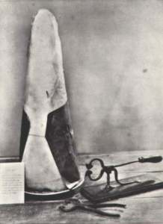
A 19th century sugar loaf and tongs
Curds can be used for so many things: cakes, tarts, pies, steamed puddings, American muffins, as a pancake topping or filling, or at its best on hot toast. Though I have always thought lemon curd ripple ice cream would be good.
Curds don’t just come in lemon yellow of course, you can make one from any fruit that the juice can be easily squeezed from: orange, grapefruit, passion fruit and pineapple are all ones I have spotted at one time or another.
Here’s my recipe for lime curd. Have a go at making it; it’s very easy to make because it’s difficult to curdle the eggs as they are stabilised somewhat by the acid and egg whites. It is wonderfully tart and not too sweet. Honestly, you’ll never go back to the bought stuff.

Lime Curd
This recipe makes around 1 UK pint (that’s 20 fl oz for any non-Brits). If you think things might be too sharp, add an extra egg and a couple of ounces of butter.
Ingredients
the zest and juice of 5 limes
5 oz salted butter
8 oz sugar cut into small cubes
4 large eggs
Set a mixing bowl over a simmering saucepan of water and add the lime zest and juice, butter and sugar.
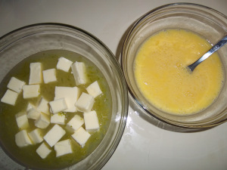
Let it warm up, the sugar dissolve and the butter melt. Beat the eggs in a separate bowl and strain through sieve into the juice. Stir with a wooden spoon until the eggs have amalgamated and thicken – this will take at least five minutes. When very thick, take off the heat but keep stirring for a minute or two as the eggs may carry on cooking if left in contact with the still hot bowl’s inner surface.
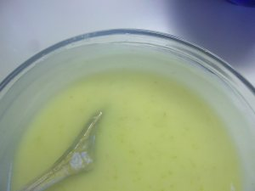
Pot into sterilised jars and allow to cool. Unless you have a nice cool larder, I would store them in the fridge, especially once opened.

