Carrot cake us
http://toriavey.com/toris-kitchen/2013/11/american-cakes-carrot-cake/

CAKE INGREDIENTS
- 2 1/4 cups all-purpose flour, preferably unbleached, or 1½ cups all-purpose flour and ¾ cup whole wheat flour (9.5 ounces/275 grams)
- 2 cups granulated sugar, or 1½ cups granulated sugar and ½ cup packed light brown sugar (14 ounces/400 grams)
- 2 teaspoons ground cinnamon
- 3/4 teaspoon ground ginger, allspice, nutmeg, or cloves, or ¼ teaspoon ground ginger and ¼ teaspoon ground nutmeg
- 2 teaspoons double-acting baking powder
- 1 teaspoon baking soda
- 1 teaspoon salt
- 1 1/2 cups vegetable or peanut oil (11.25 ounces/325 grams)
- 4 large eggs, lightly beaten (¾ cup/7 ounces/200 grams)
- 2 teaspoons vanilla extract
- 3 1/2 cups lightly packed finely grated carrots (6 to 8 medium/14 ounces/400 grams)

CAKE ADDITIONS (OPTIONAL)
- 1 cup raisins, chopped pitted dates, or blueberries (optional) (5 ounces/140 grams)
- 1 cup shredded coconut (optional) (3 ounces/85 grams)
- 1 cup toasted and coarsely chopped pecans or walnuts (optional) (4 ounces/115 grams)
- 1 cup canned crushed pineapple, drained (optional) (8 ounces/225 grams)

CREAM CHEESE FROSTING INGREDIENTS
- 2 cups cream cheese, softened (16 ounces/455 grams)
- 10 tablespoons unsalted butter, softened (1¼ sticks/6 ounces/170 grams)
- 1 tablespoon pure vanilla extract
- 2 tablespoons fresh lemon juice, 2½ tablespoons sour cream, or 1 tablespoon orange liqueur (optional)
- Pinch of salt
- About 3 cups confectioners’ sugar, sifted (12 ounces/340 grams)
- Marzipan carrots or about 1 cup toasted coconut for garnish (optional)
Get Ingredients
Powered by Chicory

Prep Time: 20 Minutes
Cook Time: 30 Minutes
Total Time: 3 Hours
Servings: Two 9-inch rounds, three 8-inch rounds, two 8-by 4-inch loaves, or one 13- by 9-inch or 10-inch Bundt cake. 12 to 16 servings

To Make Cake
- Position a rack one-third up from the bottom of the oven. Preheat the oven to 350°F (325°F for a convection oven). Grease and lightly flour two 9- by 1½-inch round pans, three 8- or 9- by 1½-inch round pans, two 8-by 4-inch loaf pans, one 13- by 9- by 2-inch baking pan, or one 10-inch (12-cup) Bundt or tube pan.
- Sift together the flour, spices, baking powder, baking soda, and salt. In a large bowl, beat together the eggs and sugar. Beat in the oil and vanilla. Stir in the flour mixture.

image: http://toriavey.com/images/2013/11/Carrot-Cake-on-TheHistoryKitchen.com_-2-640x480.jpg
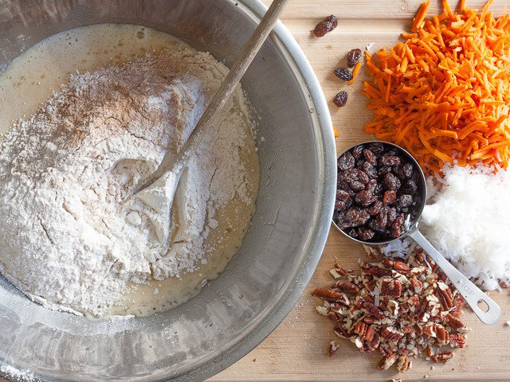Add the carrots and, if using, 1 to 2 cups any combination of additions. It will be a rather loose batter.

image: http://toriavey.com/images/2013/11/Carrot-Cake-on-TheHistoryKitchen.com_-3-640x480.jpg
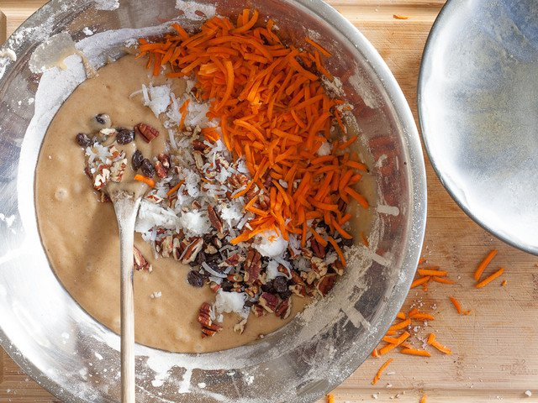Pour into the prepared pans. Bake until a tester inserted in the center comes out nearly clean and the cake springs back when lightly touched, 30 to 40 minutes for 9-inch pans; 20 to 30 minutes for 8-inch pans; 45 to 55 minutes for a 13- by 9-inch pan; or about 1 hour for a Bundt pan or loaf pan.

image: http://toriavey.com/images/2013/11/Carrot-Cake-on-TheHistoryKitchen.com_-4-640x480.jpg
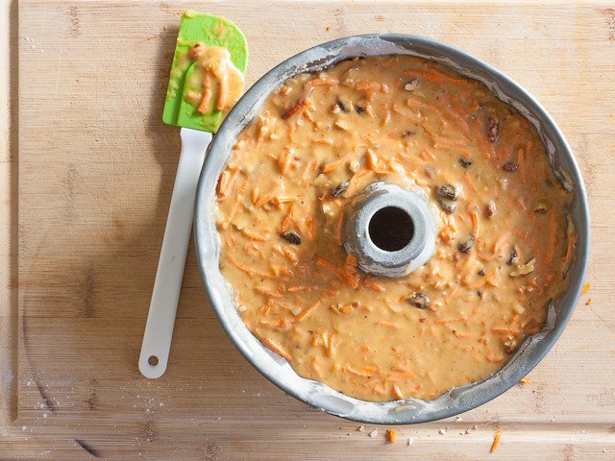Let cool in the pans for 15 minutes, then remove the cake to a wire rack and let cool completely, at least 1½ hours. Wrap in plastic wrap and store at room temperature for up to 3 days, in the refrigerator for up to 1 week, or the freezer for up to 3 months.

To Make Frosting
- In a medium bowl, beat the cream cheese and butter until smooth, about 1 minute. Blend in the vanilla and, if using, lemon juice.

image: http://toriavey.com/images/2013/11/Carrot-Cake-on-TheHistoryKitchen.com_-5-640x480.jpg
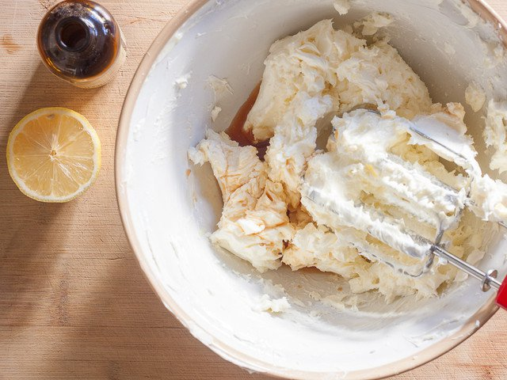Gradually add the sugar and beat until smooth and of a spreading consistency, about 4 minutes.

image: http://toriavey.com/images/2013/11/Carrot-Cake-on-TheHistoryKitchen.com_-6-640x480.jpg
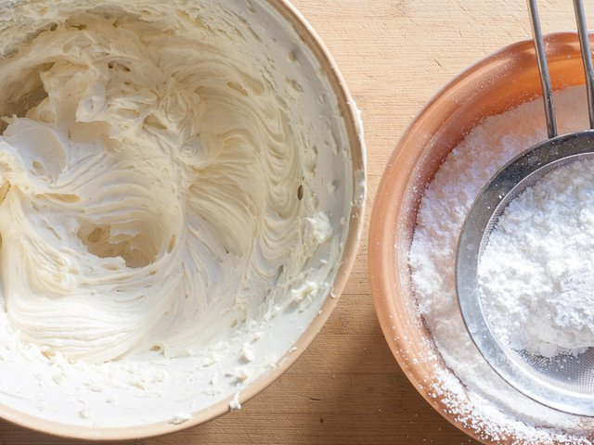Spread the top and sides with the frosting. If desired, garnish with marzipan carrots or toasted coconut. Refrigerate for at least 1 hour.

