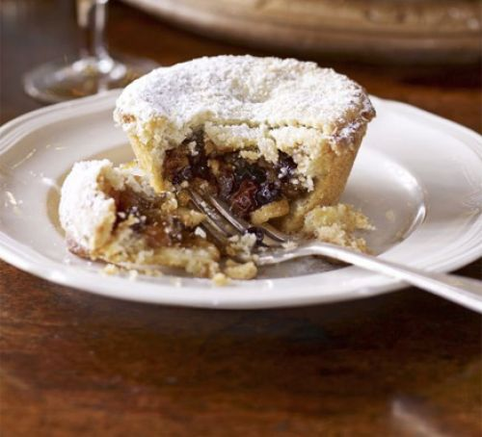

Mince pies

Ingredients
- 1 large jar mincemeat (about 600g)
- little icing sugar, or caster sugar for sprinkling

For the pastry
- 225gr plain flour
- 100g unsalted butter, softened
- 125g caster sugar (optional)
- 1 large egg or 3 to 5cl cold water
plus 1 beaten egg for glazing

Method
- Place the flour and butter in a bowl and rub together to a crumb consistency. (optional add the sugar and the egg), gradually add enough water, mixing with a fork, to form a stiff but pliable dough Tip out onto a lightly floured surface
- Knead lightly for a few minutes until smooth, but do not over-knead as this can make the pastry tough. Wrap the pastry in cling film and chill for at least 15 mins.
- Heat oven to 220C/230C /gas 7-8. Roll out the pastry to 3mm thick. Using a round cutter (about 10cm), cut out 7 to 8 bases and place them into muffin trays. Spoon 1tbsp mincemeat. Put 11⁄2 tbsp mincemeat into the middle of the pastry and spread it out to cover the base. Brush the edge of each pie with a little beaten egg. Re-roll out the pastry to cut 7cm lids and press them on top to seal. Glaze with the rest of the egg, sprinkle with caster sugar or icing sugar, then make a small cut in the tops.
- Bake mince pies for 15-20 mins until golden brown. Leave to cool before releasing them from the muffin trays and dusting with icing sugar. Serve.hot or cold
ENJOY!

